**PLACEMENT EMPOWERMENT PROGRAM**

**CLOUD COMPUTING AND DEVOPS CENTRE**

Back Up and Restore a Cloud Instance : Take a snapshot of your cloud VM. Terminate the VM and restore it from the snapshot.

Name: SHARUKA S Department: ADS

**Steps**

Step 1:

Launch an Ec2 instance.(Backup Instance)

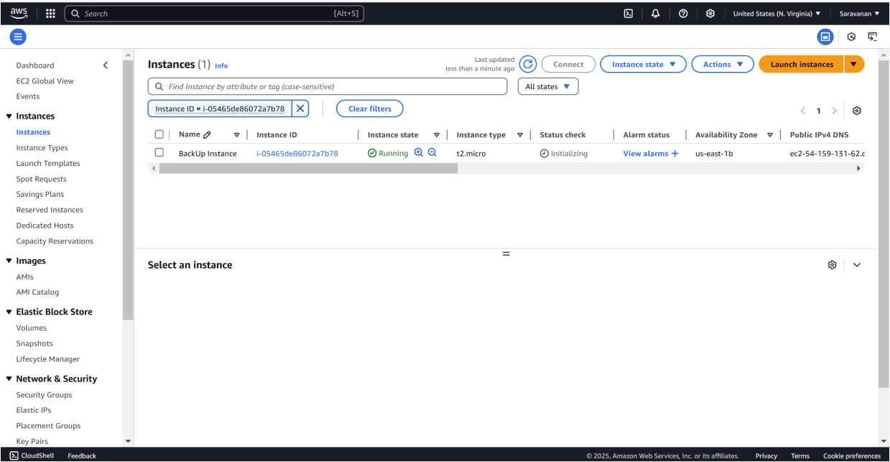

Step 2:

To create a new EBS volume in AWS, go to the EC2 Dashboard , In the left-hand menu, under Elastic Block Store, click on Volumes, then click the Create Volume button. Select General Purpose SSD for the volume type, set the size 8 GiB, within Free Tier limits, and choose the availability zone that matches your EC2 instance. Leave the other options as default, then click Create Volume. Be sure to note the Volume ID for future reference.

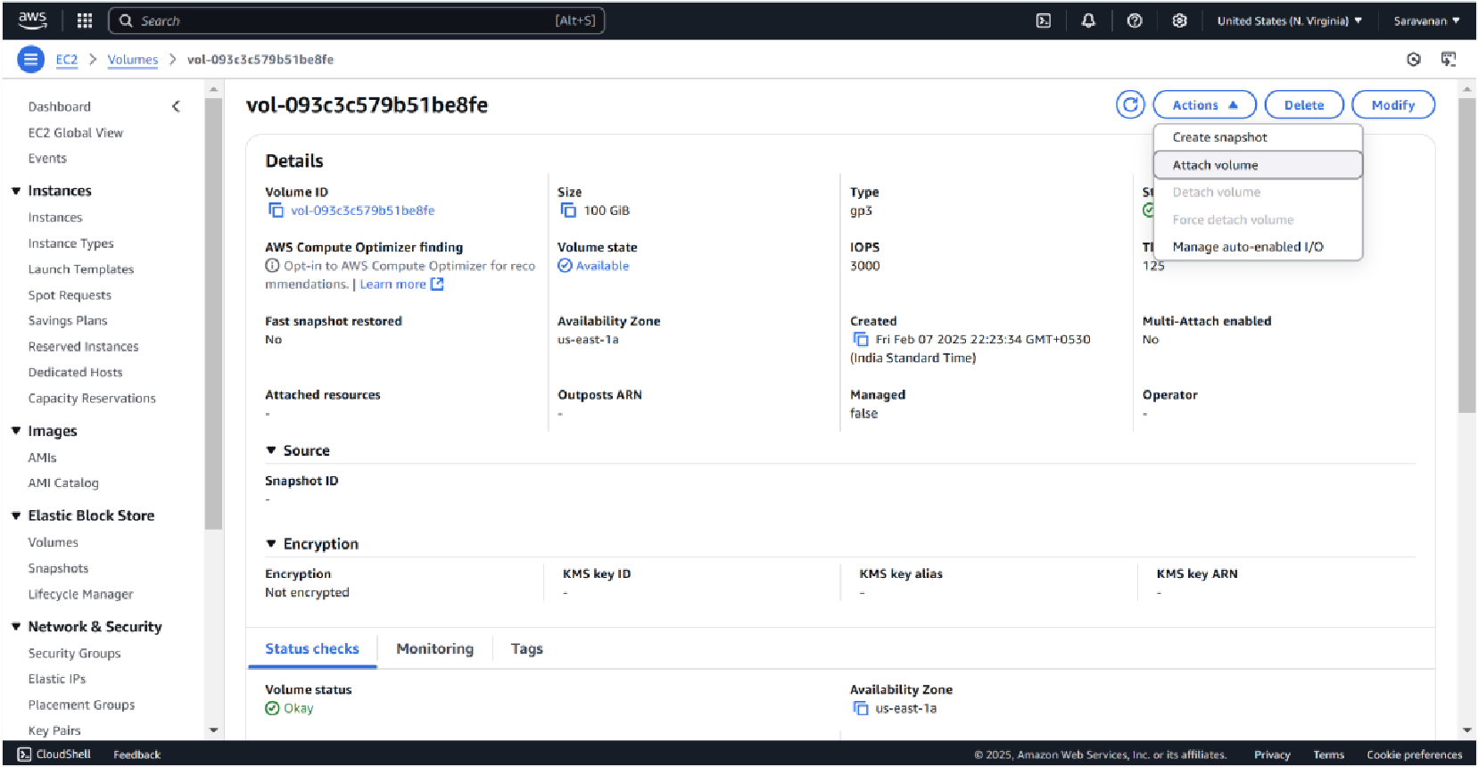

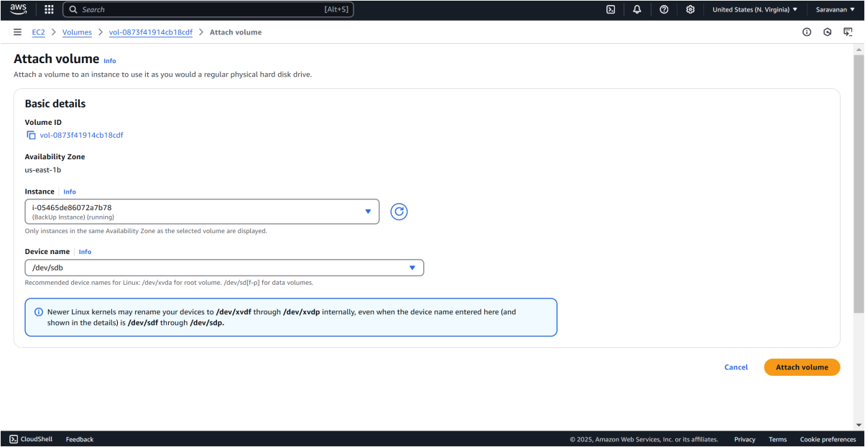

Step 3:

To create a snapshot of your EBS volume, navigate to the EC2 Dashboard and click on Volumes under the Elastic Block Store section. Locate the volume attached to your instance (it should match the instance name or ID), select it, then click Actions > Create Snapshot. Add a meaningful description (e.g., "Snapshot of Backup Instance on Feb 7") and click Create Snapshot. To monitor its status, go to Snapshots under Elastic Block Store in the left menu and wait for the status to change to Completed.

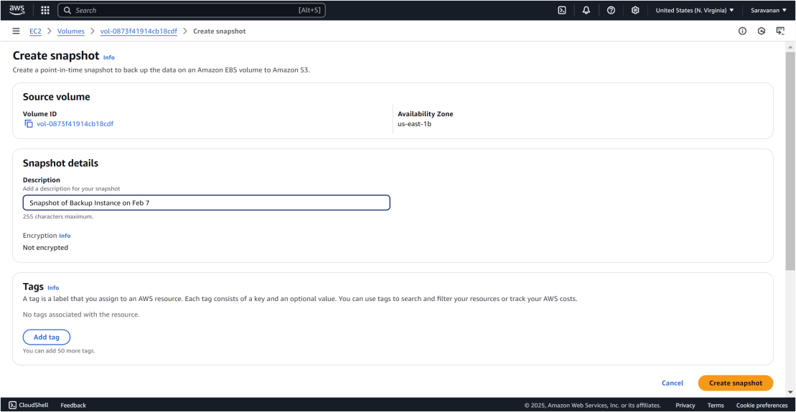

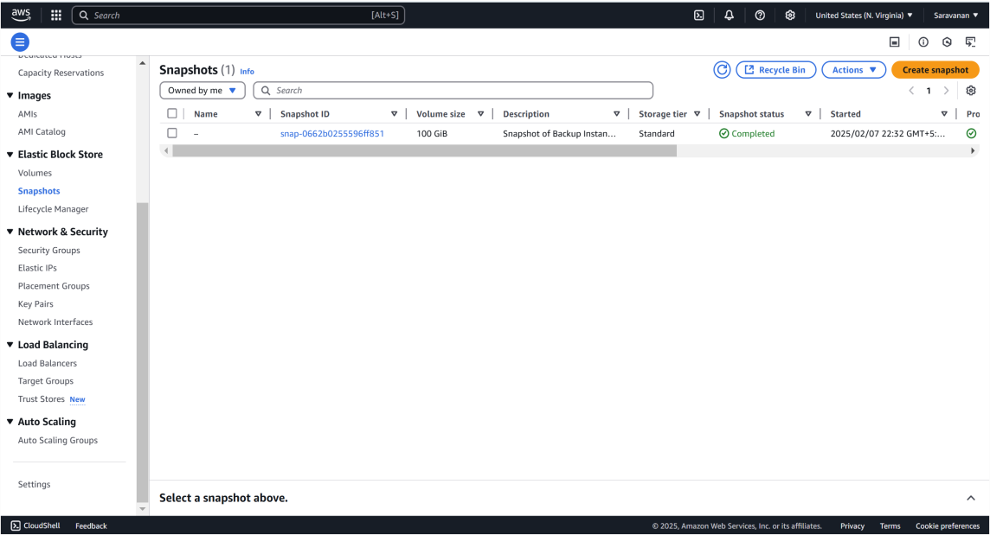

Step 4:

To terminate an EC2 instance, navigate to the EC2 Dashboard and click on Instances under the Instances section. Locate the instance you want to terminate, then select it and click Actions > Instance State > Terminate Instance. Confirm the termination by clicking Terminate, and refresh the page after a few moments to see the instance state change to Terminated.

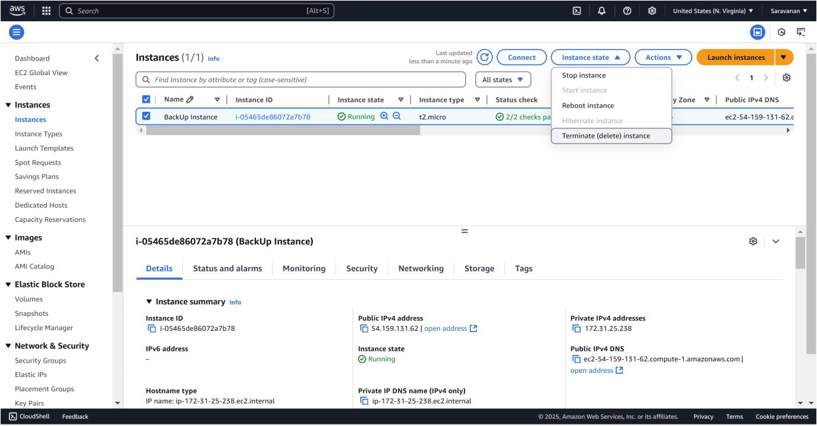

Step 5:

To create a new volume from the snapshot, go to the EC2 Dashboard and click on Snapshots under the Elastic Block Store section in the left menu. Select the snapshot you created earlier, then click Actions at the top and choose Create Volume. In the configuration settings, leave the Size as is and select the same Availability Zone where you want to restore your instance (e.g., us-east-1a). Finally, click Create Volume to complete the process.

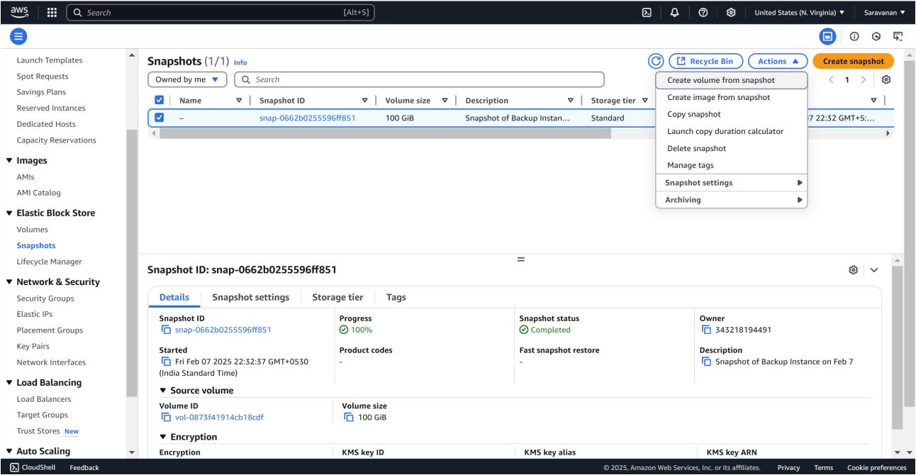

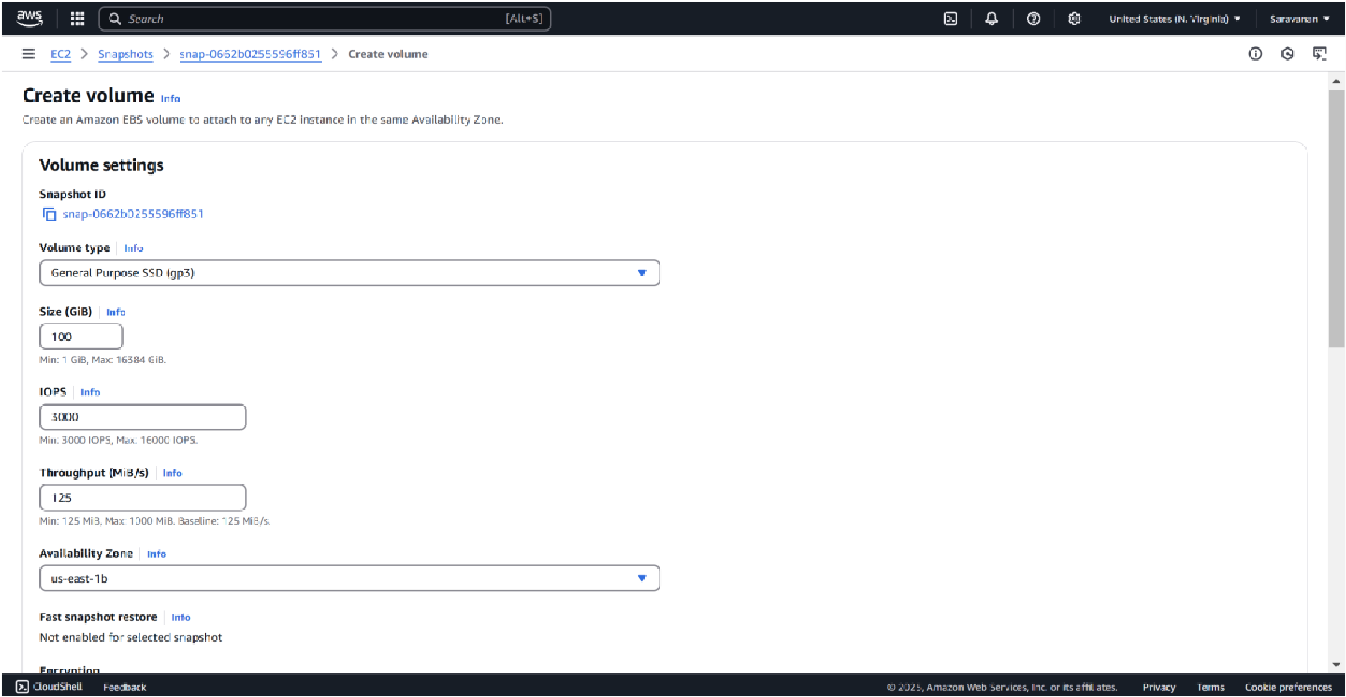

Step 6:

To launch a new instance, go to the EC2 Dashboard and click Launch Instances. Set the name of the new instance and choose the same AMI as the original instance. Select t2.micro for the instance type (Free Tier eligible). Configure the instance as needed, but skip the storage section for now.

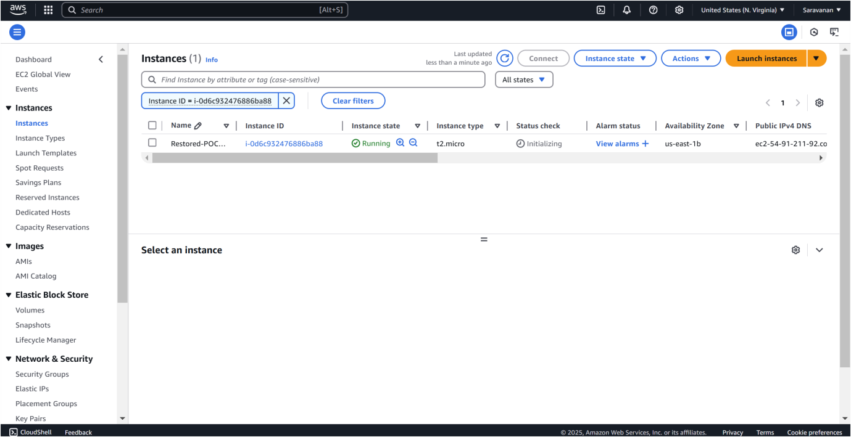

Step 7:

To attach the volume to the instance, first, stop the instance temporarily after it is launched by selecting the new instance, then click Actions > Instance State > Stop Instance. Next, go to Volumes in the left menu and select the new volume created from the snapshot. Click Actions > Attach Volume, and in the pop-up window, choose the new instance to attach the volume.

